
Investigating the Association Between Cardiovascular Health Indicators and Individual Characteristics
By Weiyi Huang, Aaron Niecestro, Yuzhou Pan, Alison Stephens

May 11, 2025
University Of Texas Health Science Center at Houston
Applied Multivariate Data Analysis
Introduction

Cardiovascular and metabolic health are influenced by a complex interplay of demographic and physiological factors.^{2,3} Understanding how variables such as age, gender, body mass index (BMI), and hypertension status jointly and independently affect vital health indicators, such as pulse rate, blood pressure, and glucose levels, is critical for advancing personalized medicine and improving population health outcomes.⁶ This study aims to investigate how these factors predict key health indicators and interact to shape overall metabolic regulation. By analyzing these relationships, we can identify which factors contribute most significantly to health risks and how they might be used to inform more accurate, individualized prevention and treatment strategies. Additionally, by examining multiple factors simultaneously, we seek to control for confounding influences and draw more precise conclusions about the drivers of cardiovascular and metabolic health.

Description of the Data

The dataset analyzed in this study contains health-related information from 5,437 patients and includes 14 independent variables encompassing demographic details, clinical measurements, and medical history. Data collection was conducted by researchers from United International University and Southeast University in Bangladesh (Prama et al.).¹ To ensure data quality and relevance, preprocessing steps were applied to focus solely on adult participants and to exclude physiologically implausible or emergency medical values. Specifically, records were retained only if body mass index (BMI) ranged between 15 and 55, pulse rate was at least 40 beats per minute (reflecting a minimum of healthy athletic baselines), systolic blood pressure did not exceed 210 mmHg (avoiding hypertensive crisis), and glucose levels ranged between 4.0 and 13.3 mmol/L to exclude cases requiring urgent medical intervention. These cleaning criteria ensured the dataset reflected a population suitable for general cardiovascular and metabolic health analysis. After the data cleaning was completed, we had 5,046 adult patients and 14 independent variables encompassing demographic details, clinical measurements, and medical history. All statistical analysis was completed using R version 2023.12.1 and SAS version 9.4.

Data Transformation

Because many multivariate statistical methods rely on the assumption of normality, the response variables—pulse rate, systolic blood pressure (SBP), diastolic blood pressure (DBP), and glucose levels—were evaluated and transformed to better approximate normal distributions. The Box-Cox transformation method was applied to each of these variables, yielding lambda transformation parameters of approximately 0.167 for pulse rate, -0.562 for glucose, -0.589 for SBP, and 0.029 for DBP. These transformations were implemented using R’s boxcox function and were chosen to improve the statistical validity of subsequent analyses. While transformation enhanced the normality of each variable to some extent, perfect multivariate normality was not achieved. Nonetheless, the transformed data were deemed more suitable for further modeling and hypothesis testing under the assumption of approximate normality with a large sample size than the non-transformed data (Figure 1).

Statistical Methods

Although Wilks’ Lambda was used to test the significance of predictors in the final multivariate model, it was not employed during exploratory data analysis (EDA). EDA focused on summarizing and understanding variable distributions, data cleaning, and assessing general trends rather than conducting formal hypothesis tests.
To address the research questions, a suite of multivariate statistical techniques was employed using R and SAS. First, a one-sample Hotelling’s T² test using R was used to evaluate whether the sample’s mean vector of health measurements significantly differed from a hypothesized population mean vector. This test was performed on both the four core response variables and a five-variable vector consisting of the four core response variables, including age. In both cases, the null hypothesis was rejected, indicating that the observed means were significantly different from the reference population. Upon further analysis, we found that the null hypothesis vector was very sensitive to the number of decimal places. Following this, one-way and two-way multivariate analyses of variance (MANOVA) were conducted to examine the effects of BMI, gender, and hypertension status on the combined health outcomes. One-way MANOVA analysis was completed using R, while the Two-Way MANOVA was completed using SAS. The one-way MANOVA results showed statistically significant differences in the response variables across each of these categorical factors. (Table 5) The two-way MANOVA allowed for the exploration of joint and interaction effects, providing more nuanced insights into how these predictors interact (Table 6).
To further account for the continuous influence of age as a covariate, multivariate analysis of covariance (MANCOVA) was applied. This method helped isolate the effects of BMI, gender, and hypertension status while statistically controlling for the effect of age. Post-hoc analyses using confidence intervals were conducted to pinpoint which groups differed significantly on each response variable. Finally, multivariate linear regression models were developed to quantify the relationships between predictors and health outcomes. Two nested models were compared: one including age, gender, and BMI, and a second incorporating hypertension status. The second model demonstrated a superior fit based on AIC criteria and a statistically significant likelihood ratio test, confirming that hypertension status contributes meaningfully to the prediction of health outcomes. This was confirmed to be the best model without interaction using one-way and two-way MANOVA, MANCOVA, and full-reduced model testing.

Results

The results of the analyses consistently indicated that BMI, hypertension status, gender, and age play significant roles in predicting cardiovascular and metabolic health indicators. In the one-way MANOVA analyses, each categorical variable—BMI, gender, and hypertension—was found to significantly influence the response variables. Notably, higher BMI categories (overweight and obese) were associated with elevated blood pressure and glucose levels, consistent with existing clinical literature. Gender differences were most pronounced in pulse rate, with males generally exhibiting higher values. Hypertension status emerged as a particularly strong predictor of both systolic and diastolic blood pressure, as well as glucose levels.
Results from the one-sample Hotelling’s T² analysis (Table 4) indicated that the mean values of the transformed cardiovascular and metabolic variables, as well as age, significantly deviated from the hypothesized population means. The confidence intervals were narrow, suggesting stable estimates. Notably, systolic blood pressure had an exceptionally tight confidence interval of (1.601, 1.601), indicating negligible variability. Bonferroni correction yielded slightly narrower intervals, increasing the stringency of statistical inference. For instance, the interval for transformed glucose narrowed from (1.173, 1.180) to (1.174, 1.179) after correction. The one-way MANOVA results by BMI category (Table 5) revealed multiple statistically significant group differences. Systolic and diastolic blood pressure were significantly higher in obese participants compared to healthy-weight individuals, with confidence intervals (-0.0066, -0.0023) and (−0.1533, -0.0709), respectively. Significant differences were observed between the healthy and overweight groups for the blood pressure measurements. For example, the diastolic blood pressure was significantly higher in overweight individuals compared to healthy individuals (CI: −0.0910, −0.0048). Diastolic blood pressure also significantly differed between underweight and other BMI categories. Specifically, obese individuals had significantly higher diastolic BP than underweight individuals (CI: 0.1031, 0.1943). However, no significant differences in pulse rate were observed across BMI groups, as all confidence intervals include zero.
The two-way MANOVA models reinforced these findings. BMI remained a significant predictor of blood pressure levels, while gender effects persisted for pulse rate and diastolic blood pressure. However, interaction effects between gender and BMI, as well as between hypertension status and gender, were not statistically significant, suggesting that these predictors operate largely independently rather than synergistically. The MANCOVA analyses confirmed that age had a confounding influence on the relationships between categorical predictors and health outcomes. For example, when age was included as a covariate, it significantly affected the confidence intervals associated with group differences by BMI, gender, and hypertension status.
In the multivariate linear regression analysis, the model that included all four predictors—age, gender, BMI, and hypertension status—was the best-fitting model, with the lowest AIC value and statistically significant model comparison results. This model explained a substantial portion of the variability in the transformed health outcomes and provided a robust framework for understanding how these individual characteristics jointly influence cardiovascular and metabolic regulation.
The two-way MANOVA analysis (Table 6) examined the joint effects of BMI category and gender on the four transformed response variables: pulse rate, systolic blood pressure (SBP), diastolic blood pressure (DBP), and glucose. The results were largely consistent with those from the one-way MANOVA, with BMI continuing to show significant associations with blood pressure and glucose. Specifically, obese individuals had significantly higher systolic (CI: −0.1086, −0.0501) and diastolic blood pressure (CI: −0.1253, −0.0709) compared to healthy-weight participants. Significant differences were observed when comparing overweight participants to healthy participants. Diastolic blood pressure was also significantly elevated in obese compared to underweight individuals (CI: 0.1002, 0.1604), reinforcing the role of BMI as a key predictor. Gender differences remained statistically significant only for pulse rate (CI: 0.0573, 0.076), with males consistently exhibiting higher values. No significant gender differences were found for blood pressure or glucose levels, as the confidence intervals crossed zero. Post-hoc pairwise comparisons following MANCOVA (Table 7), which adjusted for age as a covariate, further clarified the relationships between predictors and response variables. After accounting for age, additional significant differences emerged, particularly among intermediate BMI categories. For instance, overweight individuals showed significantly higher systolic BP than underweight individuals (CI: 0.0603, 0.1001), and obese individuals had significantly higher SBP than overweight individuals (CI: 0.016, 0.0747). Notably, some directional changes in confidence intervals (marked in red) were observed compared to the one-way MANOVA, such as in the comparisons between healthy and underweight individuals (CI: 0.015, 0.047), suggesting that adjusting for age reversed the effect direction. Additionally, glucose level differences became statistically significant between overweight and healthy participants (CI: −0.0517, −0.0071) only after age adjustment. This highlights age as a meaningful confounder, influencing the interpretation of glucose-related group differences. Gender continued to show significant differences in pulse rate (CI: 0.048, 0.067) and showed a new significant effect in systolic and diastolic BP (CIs: 0.0182, 0.0367 for SBP and 0.0096, 0.0283 for DBP), which were not significant in prior MANOVA models. This suggests that gender differences in blood pressure may be masked if age is not accounted for.

Model Checking

To validate the use of multivariate statistical methods such as Hotelling’s T², MANOVA, and multivariate linear regression, key assumptions were systematically assessed. The way we checked our model was first checking multivariate normality, second checking the homogeneity of the covariance matrix, and third checking the model's significance.
The first assumption that we checked was multivariate normality. Multivariate normality was evaluated using a chi-square Q-Q plot of squared Mahalanobis distances (Figure 1). The transformed response variables (in blue) more closely followed the theoretical chi-square quantiles compared to the original data (in red), indicating that the Box-Cox transformations successfully improved normality. Additionally, the residual-based chi-square plot for the final multivariate model (Figure 2) showed reasonable adherence to the theoretical distribution, with only minor deviations in the upper tail, supporting the assumption of approximate normality of residuals. We did not use a Shapiro-Wilk test to if our model followed multivariate normality because of the following reasons: 1. our final cleaned sample still had more than five thousand observations, and 2. large sample case usually has the test statistical tests reject the null hypothesis, so we only look at the plot to confirm multivariate normality.
The second assumption for our model that we checked was the homogeneity of the covariance matrix. To assess the assumption of equal covariance matrices across groups—a key requirement for MANOVA—a D-D (distance-distance) plot was used (Figure 3). This plot compared Mahalanobis distances of predicted values and studentized residuals, and revealed no obvious patterns or heteroscedasticity, suggesting that the homogeneity assumption was reasonably met. We were unable to use a Box’s M-test since our final cleaned sample still had more than five thousand observations.
Multivariate normality and equality of covariance matrices were assessed globally for the final multivariate model. These diagnostics included Mahalanobis distance-based chi-square Q-Q plots and distance-distance plots, which supported the approximate validity of these assumptions. These checks were repeated within each subgroup in the Two-Way MANOVA model.
The final multivariate model was evaluated using Wilks’ Lambda for each predictor (Table 8). All variables—age, gender, hypertension status, and BMI category—were found to significantly contribute to the model (all p-values < 0.001), confirming their collective importance in explaining variation in the cardiovascular and metabolic response variables.

Conclusion

This study demonstrates that BMI, hypertension status, gender, and age are significant predictors of cardiovascular and metabolic health indicators. Overweight and obesity were consistently associated with elevated blood pressure and glucose levels, while males exhibited higher pulse rates than females. Hypertension status had a pervasive influence on both blood pressure and glucose, underscoring its critical role in health risk assessment. Age emerged as an important confounder, necessitating its inclusion in multivariate models to accurately interpret group differences. Collectively, these findings highlight the importance of considering multiple, interrelated factors when modeling physiological outcomes and designing targeted interventions.

Limitations

Despite the robustness of the statistical methods used, several limitations constrain the generalizability of the findings. Most notably, the dataset lacks detailed documentation about the original data collection methods. Without knowledge of whether the data were derived from medical records, surveys, or clinical measurements, questions about data reliability remain. Furthermore, the study design is observational and cross-sectional, preventing causal inference. Another limitation stems from the restricted number of predictors available; although four continuous response variables were analyzed, the predictor set was relatively narrow. Additionally, although 303 outliers were identified using Mahalanobis distance thresholds, they were not removed due to concerns about improperly excluding influential cases without sufficient justification.

Future Directions

Future research should focus on acquiring higher-quality datasets with clearer documentation of data collection procedures and a wider range of predictor variables. One potential improvement is to minimize the number of response variables by using a composite measure such as Mean Arterial Pressure (MAP) instead of analyzing systolic and diastolic blood pressure separately. Another potential improvement is to consider robust multivariate methods or nonparametric MANOVA models as alternatives to applying the Box-Cox transformation. Further post-hoc analyses may reveal more subtle group differences that were not evident in the primary analysis. Expanding the study to include data from multiple populations or healthcare centers would also enhance the generalizability of the findings. Finally, establishing more rigorous criteria for identifying and managing influential outliers would strengthen the integrity of future statistical analyses.

References:

- Prama, Tabia Tanzin, et al. DiaHealth: A Bangladeshi Dataset for Type 2 Diabetes Prediction. Mendeley Data, V1 (2024), https://doi.org/10.17632/7M7555VGRN.1.
- Ramesh, Gautam et al. Associations Between Adherence to the Dietary Approaches To Stop Hypertension (Dash) Diet and Six Glucose Homeostasis Traits in the Microbiome and Insulin Longitudinal Evaluation Study (Miles). DigitalCommons@TMC. Print.
- Li, Shengxu et al. “BMI and Waist Circumference Are Associated with Impaired Glucose Metabolism and Type 2 Diabetes in Normal Weight Chinese Adults.” Journal of diabetes and its complications 28.4 (2014): 470–476. Web.
- Il’yasova, D et al. “Prospective Association between Fasting NEFA and Type 2 Diabetes: Impact of Post-Load Glucose.” Diabetologia 53.5 (2010): 866–874. Web.
- Branch, OraLee H et al. “Relationships Between Blood Pressure Reduction, Weight Loss, and Engagement in a Digital App–Based Hypertension Care Program: Observational Study.” JMIR formative research 6.10 (2022): e38215–e38215. Web.
- Ma, Jun et al. “Quantifying the Relationships of Blood Pressure with Weight, Height and Body Mass Index in Chinese Children and Adolescents.” Journal of paediatrics and child health 48.5 (2012): 413–418. Web.
- DRIVSHOLM, T et al. “Symptoms, Signs and Complications in Newly Diagnosed Type 2 Diabetic Patients, and Their Relationship to Glycaemia, Blood Pressure and Weight.” Diabetologia 48.2 (2005): 210–214. Web.
- Kahn, Linda G et al. “Evaluating the Relationship Between Birth Weight for Gestational Age and Adult Blood Pressure Using Participants From a Cohort of Same-Sex Siblings, Discordant on Birth Weight Percentile.” American journal of epidemiology 186.5 (2017): 550–554. Web.

Appendix

Table 1: Continuous Variables Summary Statistics of the Original Data

Variable | Min | Max | Mean | Standard Deviation
Pulse Rate (bpm) | 40.00 | 133.00 | 76.49 | 12.02
Glucose (mg/dL or mmol/L) | 4.00 | 13.25 | 7.12 | 1.64
Systolic Blood Pressure (mmHg) | 62.00 | 209.00 | 133.40 | 21.92
Diastolic Blood Pressure (mmHg) | 45.00 | 119.00 | 81.89 | 12.44
Age (Years) | 18.00 | 112.00 | 45.33 | 14.13

Table 2: Categorical Variables Summary Statistics

Variable | Count (n = 5046)
Gender: Male | 1486
Gender: Female | 3560
Hypertension: Yes | 516
Hypertension: No | 4530
Underweight (15 ≤ BMI < 18.5) | 722
Healthy (18.5 ≤ BMI < 25) | 3276
Overweight (25 ≤ BMI < 30) | 827

Figure 1: Multivariate Normality Plot of Original vs Transformed Data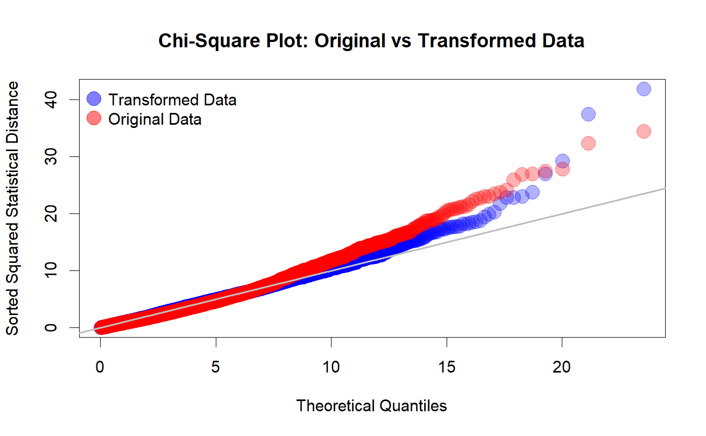

Table 3: Continuous Variables Summary Statistics of the Transformed Data

Variable | Min | Max | Mean | Standard Deviation
Transformed Pulse Rate (bpm) | 5.10 | 7.55 | 6.34 | 0.31
Transformed Glucose (mg/dL or mmol/L) | 0.96 | 1.36 | 1.18 | 0.07
Transformed Systolic Blood Pressure (mmHg) | 1.55 | 1.62 | 1.60 | 0.01
Transformed Diastolic Blood Pressure (mmHg) | 4.03 | 5.13 | 4.69 | 0.17

Table 4: One-Sampling Hotelling T² Confidence Intervals

Variable | T² Confidence Intervals | Bonferroni-Corrected Confidence Intervals
Transformed Pulse Rate | (6.325, 6.355) | (6.328, 6.351)
Transformed SBP | (1.601, 1.601) | (1.601, 1.601)
Transformed DBP | (4.679, 4.695) | (4.681, 4.693)
Transformed Glucose | (1.173, 1.80) | (1.174, 1.179)
Age | (44.665, 45.990) | (44.815, 45.840)

Table 5: One-Way MANOVA for BMI Categories

 | Pulse Rate | Systolic BP | Diastolic BP | Glucose
Healthy vs Obese | (-0.1203, 0.0379) | (-0.0066, -0.0023) | (-0.1533, -0.0709) | (-0.0173, 0.0185)
Healthy vs Overweight | (-0.0822, 0.0064) | (-0.0035, -0.0011) | (-0.0910, -0.0448) | (-0.0179, 0.0022)
Healthy vs Underweight | (-0.0549, 0.0387) | (-0.0006, 0.0020) | (0.0122, 0.0610) | (-0.0103, 0.0108)
Obese vs Overweight | (-0.0830, 0.0894) | (-0.0002, 0.0045) | (-0.0007, 0.0891) | (-0.0280, 0.0110)
Obese vs Underweight | (-0.0544, 0.1206) | (0.0027, 0.0075) | (0.1031, 0.1943) | (-0.0202, 0.0194)
Overweight vs Underweight | (-0.0281, 0.0879) | (0.0013, 0.0046) | (0.0743, 0.1347) | (-0.0050, 0.0212)
* Blue means that the confidence intervals are significant

Table 6: Two-Way MANOVA CI for BMI and Gender

 | Pulse Rate | Systolic BP | Diastolic BP | Glucose
Healthy vs Obese | (-0.035, 0.0217) | (-0.1086, -0.0501) | (-0.1253, -0.0709) | (-0.0437, 0.0371)
Healthy vs Overweight | (-0.0303, 0.0014) | (-0.057, -0.0243) | (-0.0748, -0.0444) | (-0.0474, -0.0023)
Healthy vs Underweight | (-0.0225, 0.011) | (-0.007, 0.0275) | (0.0162, 0.0482) | (-0.023, 0.0245)
Obese vs Overweight | (-0.0387, 0.023) | (0.007, 0.0705) | (0.0089, 0.0681) | (-0.0654, 0.0224)
Obese vs Underweight | (-0.0305, 0.0322) | (0.0573, 0.122) | (0.1002, 0.1604) | (-0.0406, 0.0487)
Male vs Female | (0.0573, 0.076) | (-0.0172, 0.0021) | (-0.0066, 0.0114) | (-0.0185, 0.0081)
* Blue means that the confidence intervals are significant

Table 7: Post-Hoc Analysis for MANCOVA

 | Pulse Rate | Systolic BP | Diastolic BP | Glucose
Healthy vs Obese | (-0.0415, 0.0154) | (-0.1215, -0.0676) | (-0.1315, -0.0778) | (-0.0511, 0.0285)
Healthy vs Overweight | (-0.0306, 0.0013) | (-0.0643, -0.0341) | (-0.078, -0.048) | (-0.0517, -0.0071)
Healthy vs Underweight | (-0.0298, 0.0041) | (0.015, 0.047) | (0.0239, 0.0558) | (-0.0117, 0.0357)
Obese vs Overweight | (-0.0325, 0.0294) | (0.016, 0.0747) | (0.0124, 0.0708) | (-0.0614, 0.0252)
Obese vs Underweight | (-0.0314, 0.0318) | (0.0956, 0.1555) | (0.1147, 0.1743) | (-0.0209, 0.0676)
Overweight vs Underweight | (-0.019, 0.0228) | (0.0603, 0.1001) | (0.083, 0.1227) | (0.012, 0.0708)
Male vs Female | (0.048, 0.067) | (0.0182, 0.0367) | (0.0096, 0.0283) | (-0.0011, 0.0259)
* Blue means that the confidence intervals are significant
* Red shows the direction changes from the One-Way MANOVA Confidence Intervals from Table 5

Table 8: Final Model Table

Variable | Test Statistic (Wilk’s Lambda) | P-Value | Significant?
Age | 0.8375 | < 0.001 | Yes
Gender (Male/Female) | 0.9627 | < 0.001 | Yes
Hypertensive (Yes/No) | 0.9243 | < 0.001 | Yes
BMI (Obese/  Healthy/  Overweight/  Underweight) | 0.9509 | < 0.001 | Yes
Figure 2: Final Model Normality Check

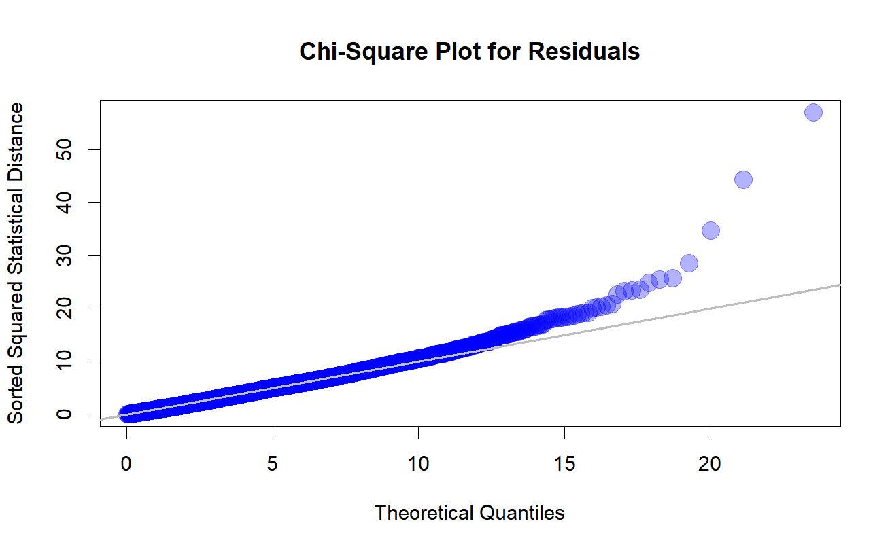

Figure 3: Final Model Homogeneity Check
